Ideation Phase
Define the Problem Statements

Date | 31 January 2025
Team ID | 6ab3db806603573ccfb383f7
Project Name | AI FAQ Assistant
Maximum Marks | 2 Marks

Customer Problem Statement – AI FAQ Assistant
Users often spend a lot of time searching through websites, documents, and other sources to find answers to frequently asked questions. They may also have difficulty identifying accurate and relevant information quickly. The AI FAQ Assistant is designed to address this problem by providing users with a simple platform where they can ask questions and receive quick, relevant, and easy-to-understand answers. The system aims to save users’ time, reduce repeated searches, and make information access more convenient and user-friendly.

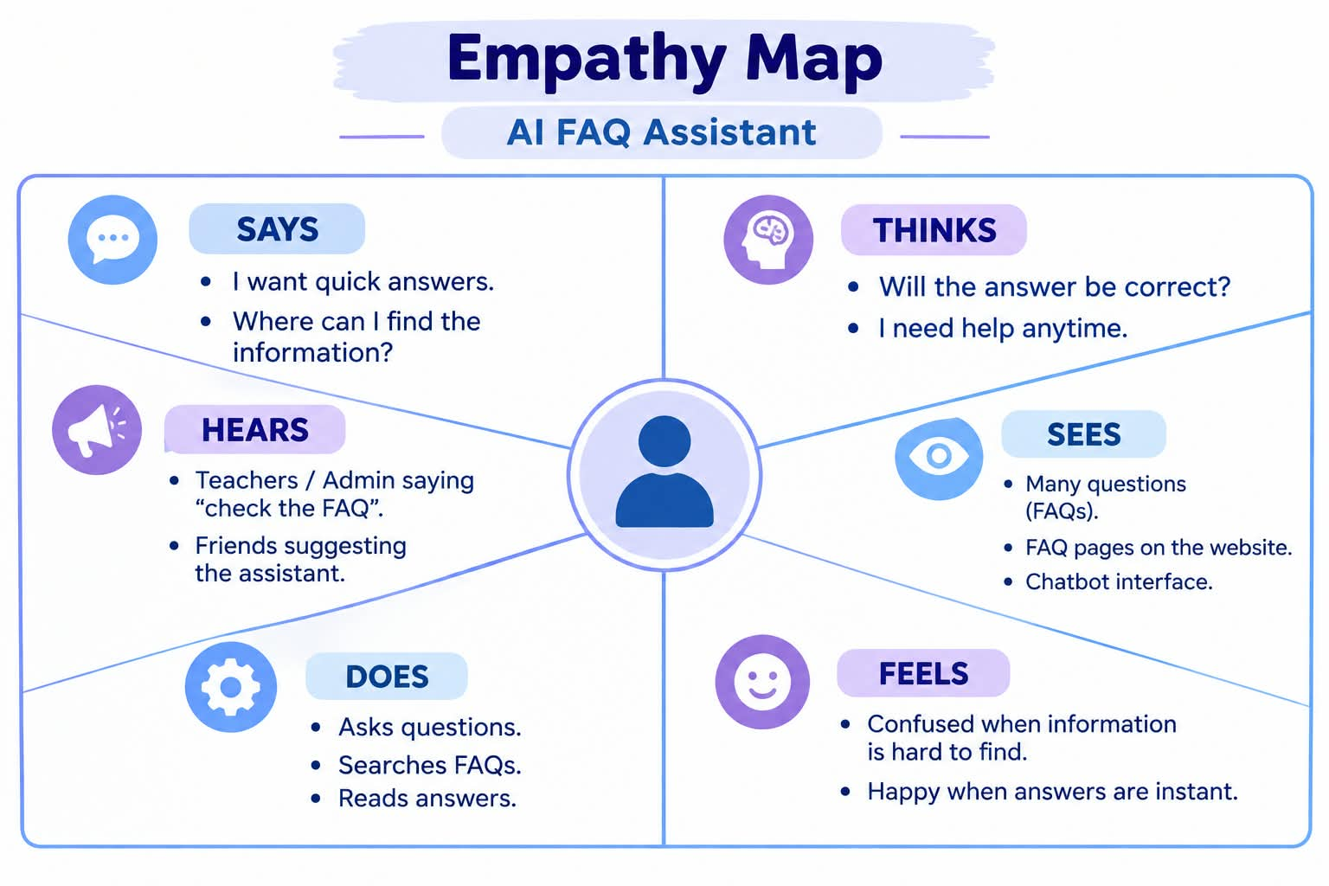
Example:
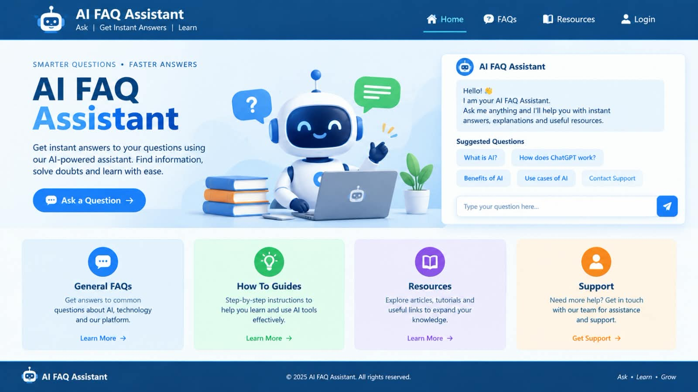
Problem Statement (PS) | I am (Customer) | I’m trying to | But | Because | Which makes me feel
PS-1 | I am a Student | I am a Student | I am a Student | I am a Student | I am a Student
PS-2 | I am an Admin | I am an Admin | I am an Admin | I am an Admin | I am an Admin

